SAVEETHA SCHOOL OF ENGINEERING
SAVEETHA INSTITUTE OF MEDICAL AND TECHNICAL SCIENCES
INSTITUTE OF CSE
CSA15- CLOUD COMPUTING AND BIG DATA ANALYTICS
LIST OF EXPERIMENTS

3. Create a simple cloud software application for Car Booking Reservation System using
any Cloud Service Provider to demonstrate SaaS include the necessary fields such as
search for cabs, from, to, rental , out station, Package type, hours/Days etc.
INPUT:
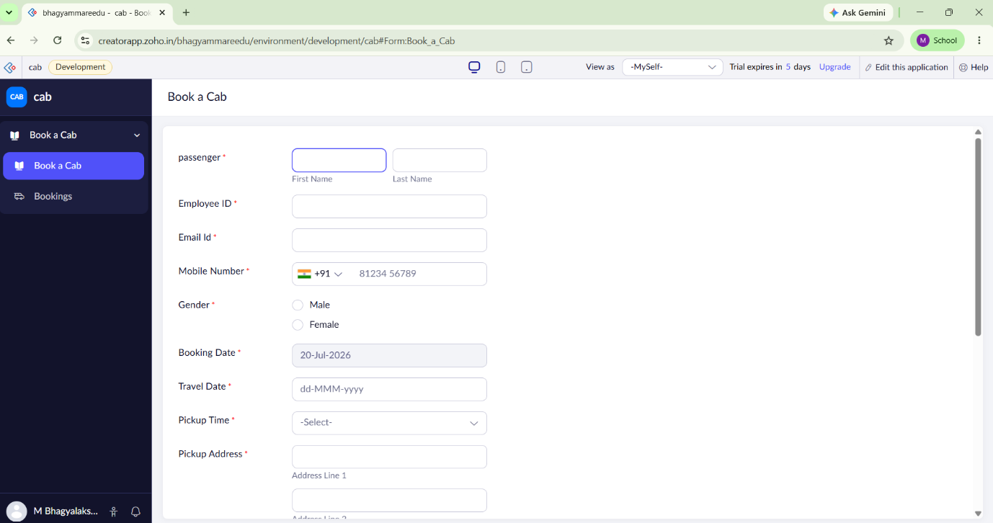

OVER VIEW:
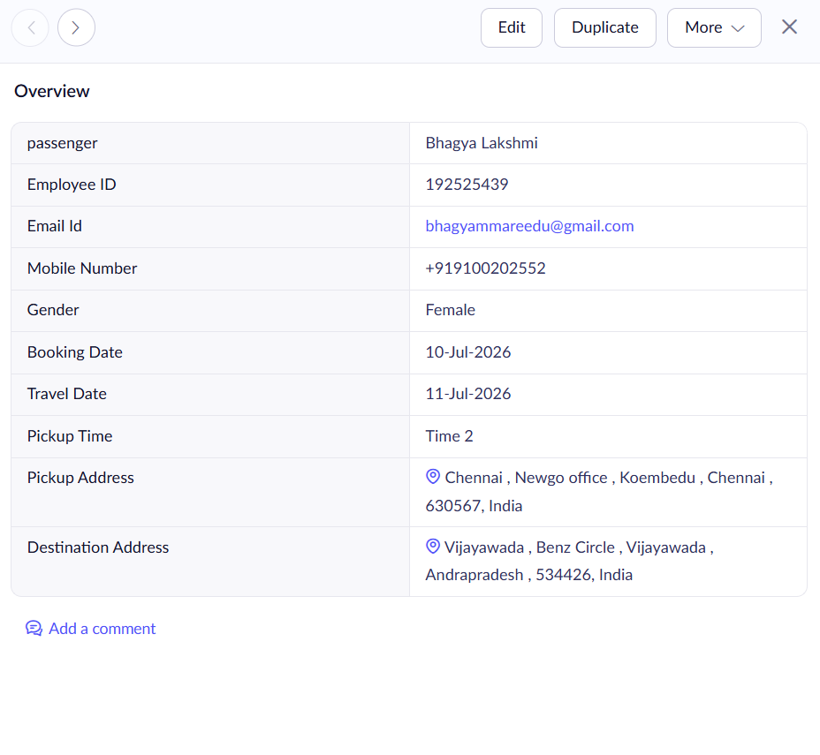
OUTPUT:
